Seeking salt: Herbivorous prairie insects can be co-limited by macronutrients and sodium

**Supplementary material**

*Appendix 1. Methodology for 2011 Sampling.*

We set-up twenty-four 20 m2 plots total in 12 areas of intact prairie at UHCC at least 250 m apart, with two plots in each area. Beginning in mid-June and ending in late July, we sampled orthopteran composition, using sweep net samples (125 cumulative sweeps in each plot), and we measured orthopteran and wolf spider abundance using ring counts and plant biomass using clip samples of 5-0.25 m2 quadrats. Orthopterans in sweep net samples were sorted to species. We also took 3 soil samples (0-10 cm), for which we measured soil moisture gravimetrically. We sorted harvested plant biomass samples to morpho-species, and dried and weighed each sample to get a species richness count and to determine diversity (using the inverse of Simpson’s D). Ground leaves from species making up 95% of the biomass in each plot were dried, and ground leaf and soil samples were sent for nutrient analyses at Sam Houston State University’s Texas Research Institute for Environmental Studies where total %C and %N were measured by combustion analysis on an elemental analyzer and micronutrients and P were measured by ICP.

*Appendix 2. Methodology for orthopteran feeding trials*

We used in-lab choice trials with leaves from 4 plant species (2 grasses and 2 forbs) collected from treatments with either ambient soil nutrients or Na, NP, or Na plus NP added. Orthopterans were collected from the field and starved overnight. Each individual was put into a pint-sized mason jar with 4 leaves from one plant species (1 leaf from each of our 4 treatments of interest). We then determine how much each individual ate of each dry leaf during a 48 hour period. We determined the proportion of an individual’s total consumption from each leaf. We used a series of paired t-tests to compare each nutrient treatment to a simulated distribution with the average of an expected proportion (0.25, the average proportion eaten of each leaf if insects had no preference) and a standard deviation that matched the standard deviation of each treatment, and used a Bonferroni correction to adjust p-values.

*Supplemental Appendix 3. Results and discussion of species-specific effects of nutrients.*

These analyses should be interpreted with caution given the smaller sample sizes for the species-by-species analyses. The most abundant species, the omnivore *Orchelimum vulgare*, was positively affected by macronutrients alone. Two other omnivorous tettigoniid species were significantly affected by nutrient treatments. Of note was that the most strongly responding species, *S. texensis*, was positively affected by macronutrients, and this effect was enhanced by the addition of Na. Males of this species were actually only found in plots with both macronutrients and Na. In addition, a *Neoconocephalus* sp. was most abundant in treatments with macronutrients and Na added, but this positive effect went away when Ca was also added. Only one acridid species, *P. atlantica*, which is a mixed feeder, was affected by nutrient treatments: it was most abundant when Na was added, but this positive effect disappeared when Ca was also added. The other 7 species were too rare in the collections to analyze individually (they were each found in only 1-5 plots out of the 128 total plots).

Our analysis of species level effects is constrained by the smaller number of individuals present in each species than in the overall total; this increased variability and made analyses of rarer species untenable. Given this caveat, nutrient treatments gave rise to some species-specific effects, resulting in changes in orthopteran community composition across the different treatments. In particular, we found: no species was affected by Na alone; the most common species across our plots, *O. vulgare*, was highly sensitive to macronutrients; and the abundance of another species, *S. texensis*, increased by ~ 400% in the macronutrient plus Na treatment. Studies that more deeply explore such potential species-specific effects have the potential to shed deeper insight into the causes and consequences of micronutrient limitation.

**Supplementary Tables.**

**Supplemental Table 1.** Combinations of macronutrients and micronutrients were the main predictors of overall orthopteran abundance and the abundance of different feeding guilds. This table summarizes the best multiple regression model for the abundance of all orthopterans and the abundance of five different functional groups of orthopterans in 2011. N=12 locations at the study site (methods in Supplemental Information Appendix 1).

|  |  |  |
| --- | --- | --- |
| **Functional group** | **Model predictors** | **R2** |
| All orthopterans | Foliar K, Soil nitrate | 0.38 |
| Grass feeders | Plant richness | 0.39 |
| Forb feeders | Foliar Na, Foliar Ca, Soil moisture (%) | 0.51 |
| Mixed feeders | Soil nitrate, Foliar C:N:P | 0.41 |
| Omnivores | Foliar N, Foliar Ca | 0.53 |
| Crickets | Soil pH, Soil P, Foliar Na | 0.79 |

**Supplemental Table 2.** Orthopteran species list and GLM results showing treatment effects on individual species. Species were tested with separate GLMs, and Bonferroni corrections were applied (we considered p-values of 0.008 significant because we used 6 total GLMs), and species present in less than 10 plots were not analyzed. Two species could only be identified to genus due to their early stages of development. Interactions that were not significant for any species are not shown.

|  |  |  |  |  |  |  |  |  |  |
| --- | --- | --- | --- | --- | --- | --- | --- | --- | --- |
| **Species** | **Macro** | **Ca** | **K** | **Na** | **Macro x Ca** | **Macro x Na** | **Ca x Na** | **Macro x Ca x Na** |  |
| *Orchelimum vulgare* | **0.001\*\*** | 0.31 | 0.74 | 0.74 | 0.83 | 0.82 | 0.99 | 0.10 |  |
| *Orchelimum concinnum* | 0.98 | 0.31 | .02 | 0.94 | 0.63 | 0.46 | 0.91 | 0.21 |  |
| *Conocephalus strictus* | 0.13 | 0.85 | 0.59 | 0.58 | 0.58 | 0.05 | 0.43 | 0.31 |  |
| *Conocephalus fasciatus* | Not enough individuals | | | | | | | | |
| *Scudderia texensis* | **>0.001\*\*\*** | 0.65 | 0.94 | .01 | 0.05 | **0.008\*** | 0.33 | 0.33 |  |
| *Amblycorpha longinicta* | Not enough individuals | | | | | | | | |
| *Neoconocephalus sp. 1 (likely robustus)* | 0.19 | 0.23 | 0.99 | 0.24 | 0.68 | 0.24 | 0.6 | **0.007\*\*** |  |
| *Oecanthus quadripunctatus* | Not enough individuals | | | | | | | | |
| *Oecanthus celerinictus* | Not enough individuals | | | | | | | | |
| *Paroxya atlantica* | 0.43 | 0.88 | 0.51 | 0.51 | 0.51 | 0.51 | **0.007\*** | 0.41 |  |
| *Melanoplus femurrubrum* | Not enough individuals | | | | | | | | |
| *Schistocera sp. 1 (likely americanus)* | Not enough individuals | | | | | | | | |
| *Leptysma marginocolis* | Not enough individuals | | | | | | | | |
| *Paratettix mexicanus* | Not enough individuals | | | | | | | | |
| *Tettigidea lateralis* | Not enough individuals | | | | | | | | |

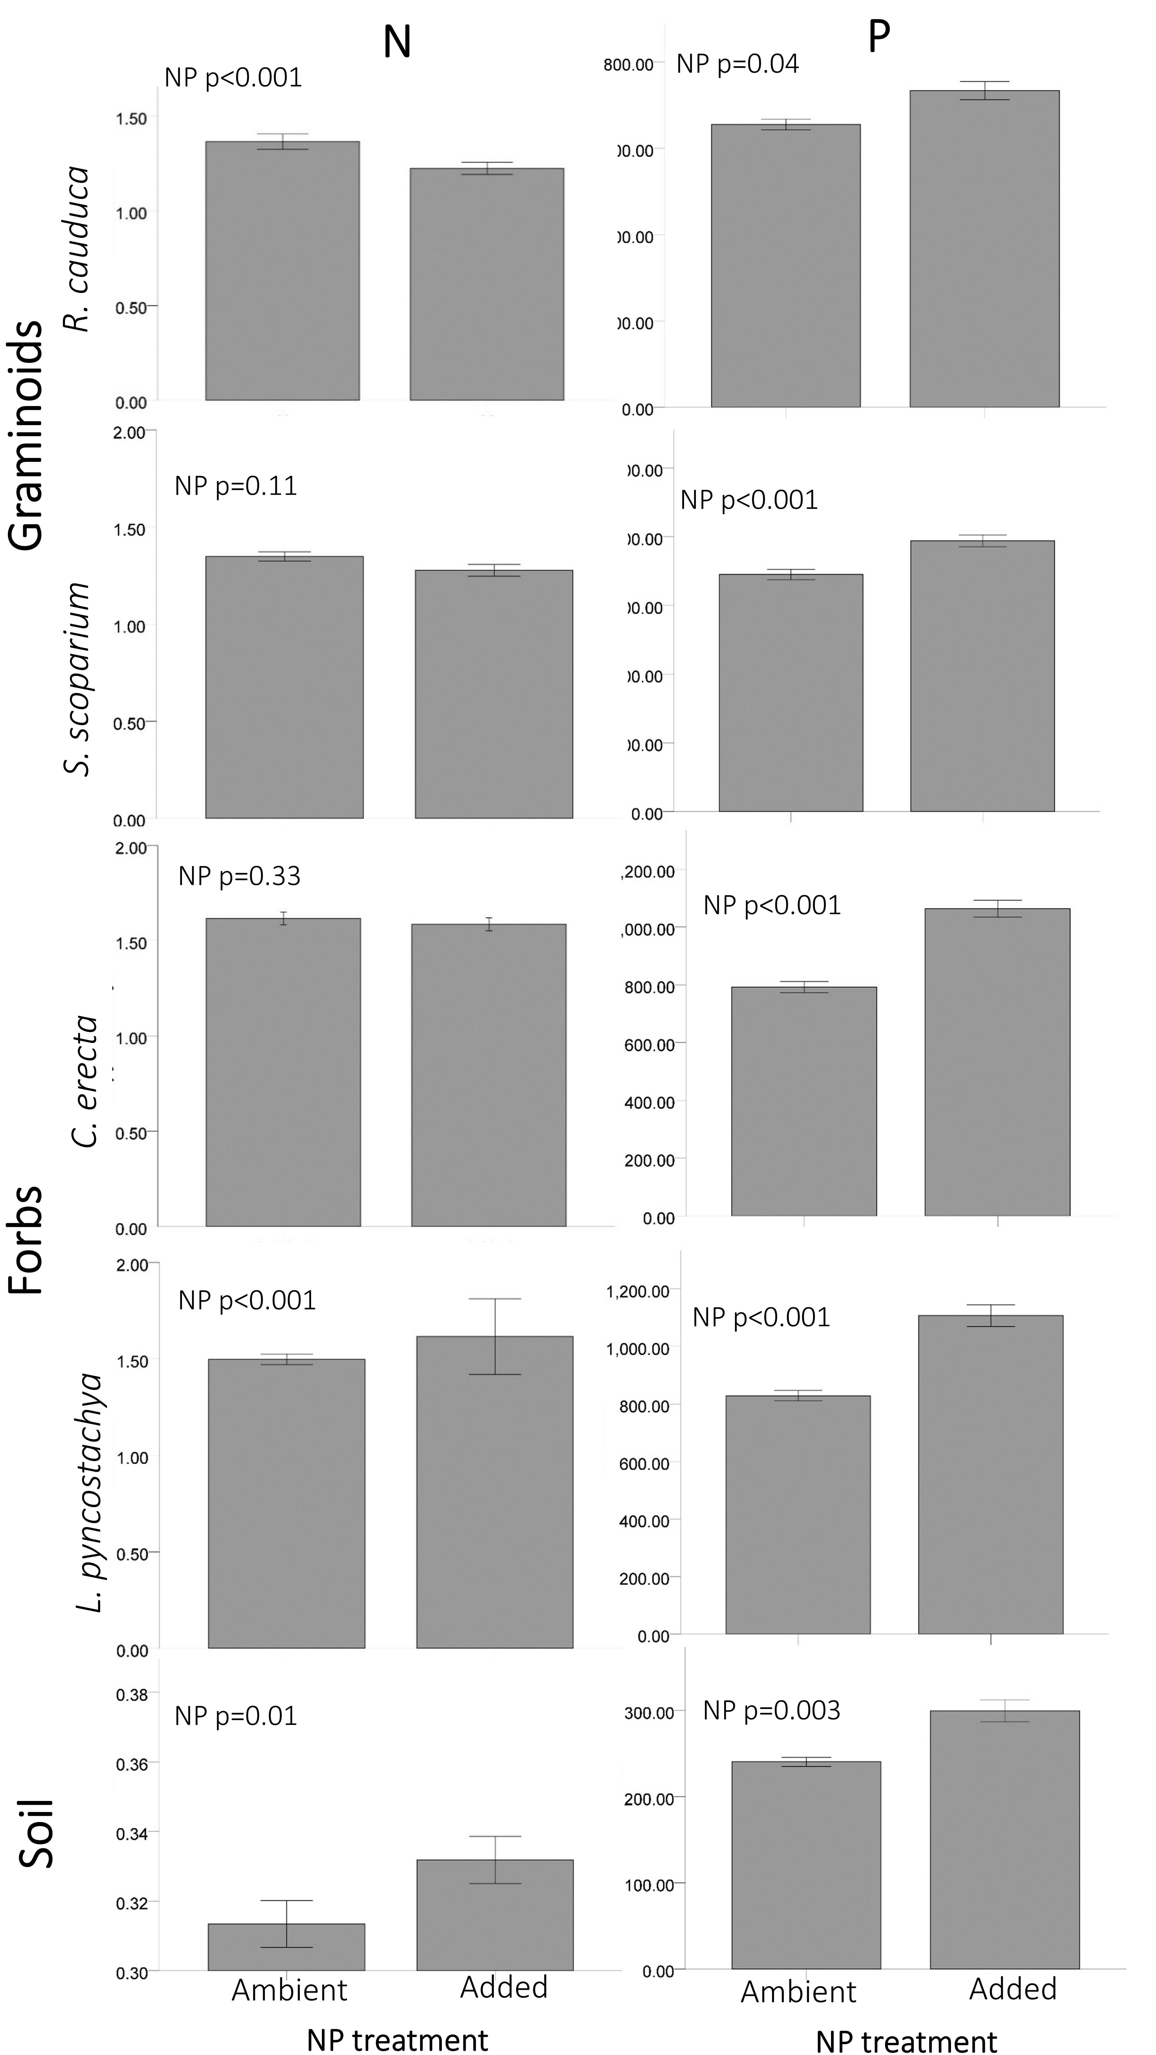

**Supplemental Figure 1.** Macronutrient effects on foliar and soil N (% of dry mass) and P (mg/kg of dry mass). Bars are means ± SE. The macronutrient addition treatment increased both N and P in the soil when added to the soil, but only P was consistently higher in foliage.

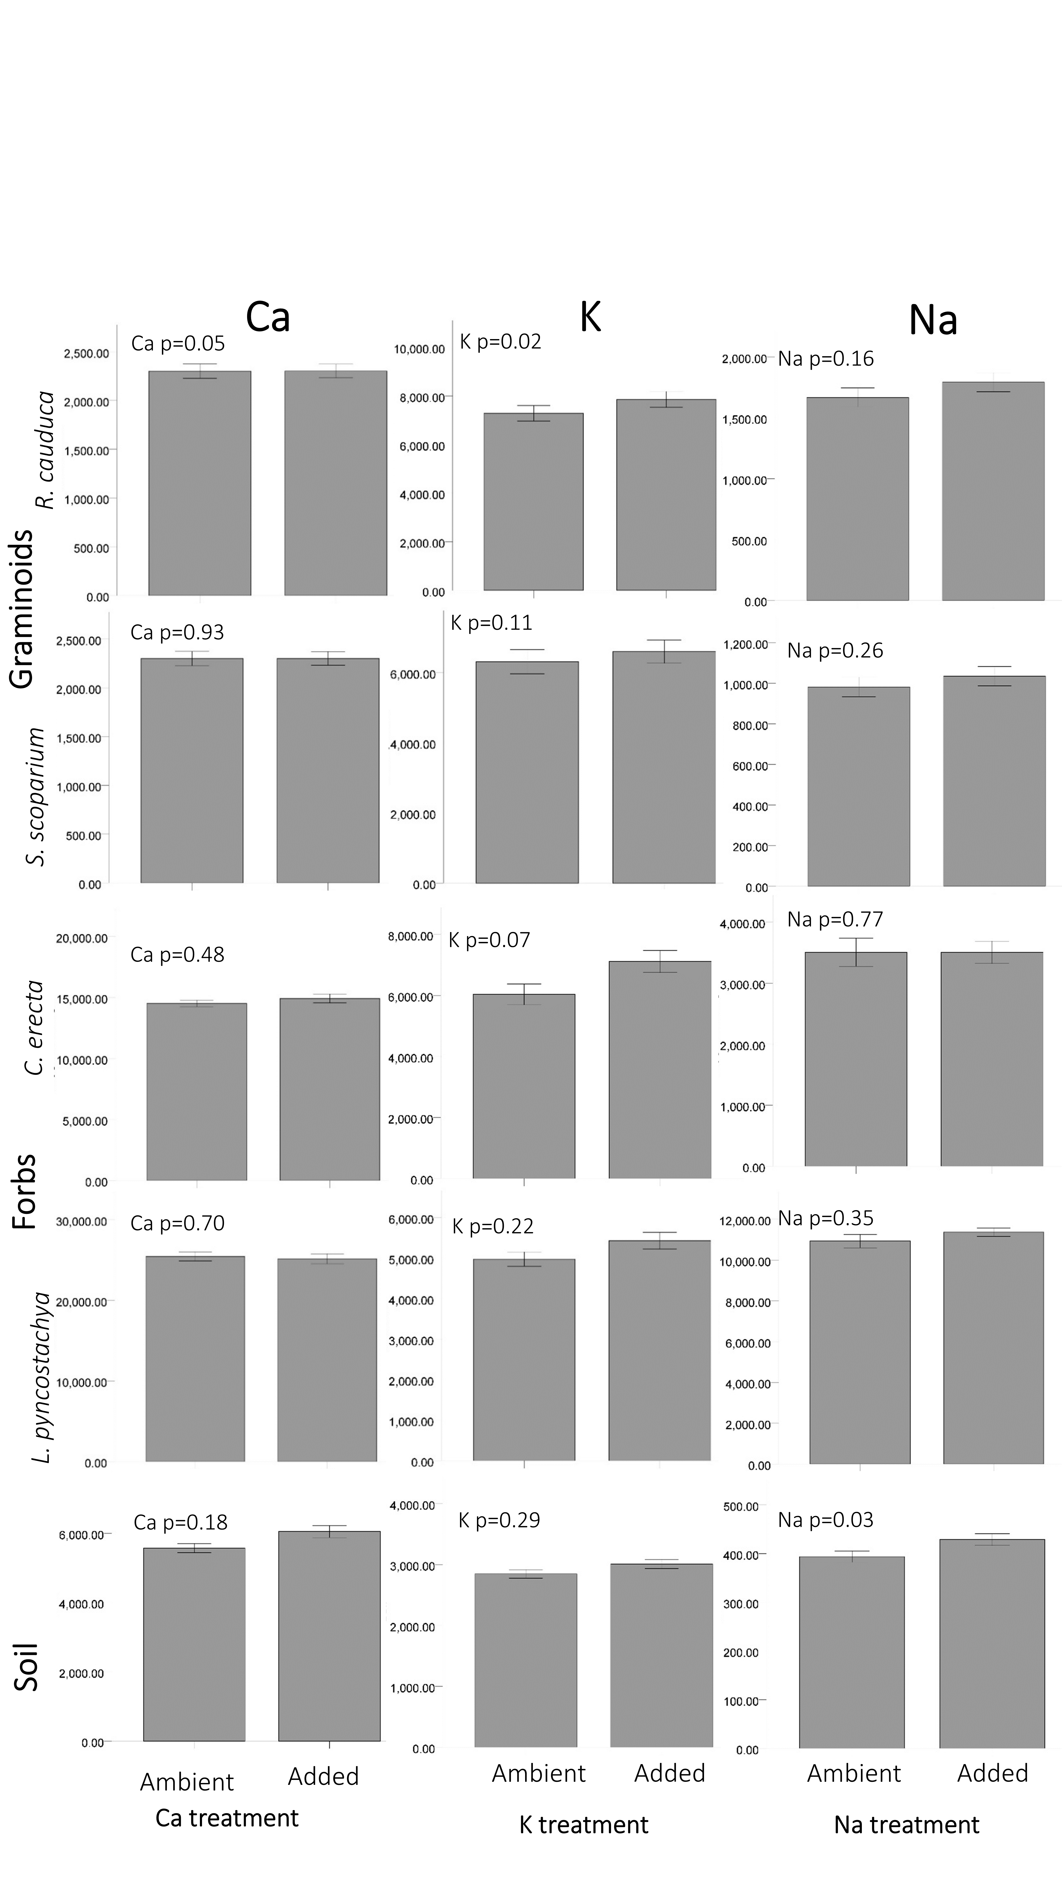

**Supplemental Figure 2.** The effects of each micronutrient addition treatment on foliar and soil concentrations (mg/kg) of each of these respective nutrients. Many treatments did not increase the concentration of their respective micronutrients in leaves. Bars are means ± SE; treatments are pooled across plots both with and without macronutrients.

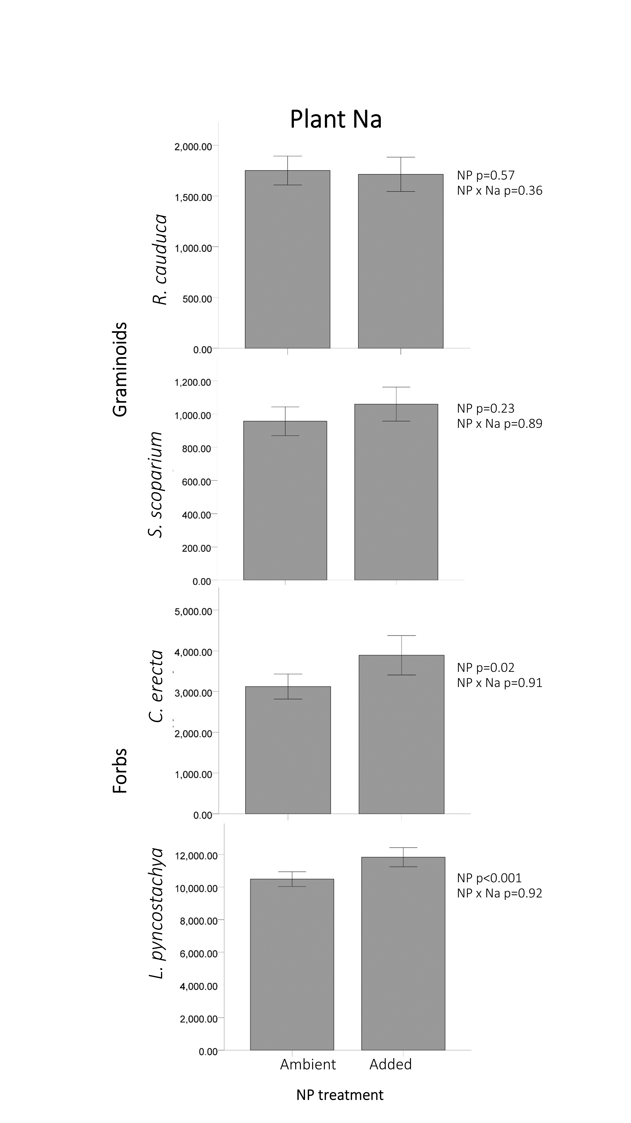

**Supplemental Figure 3.** The effects of macronutrients on the Na content (mg/kg) in leaves of 4 plant species. Macronutrients increased the Na in the two forb species sampled (*L. pyncostachya* and *C. erecta*). Bars are means ± SE.

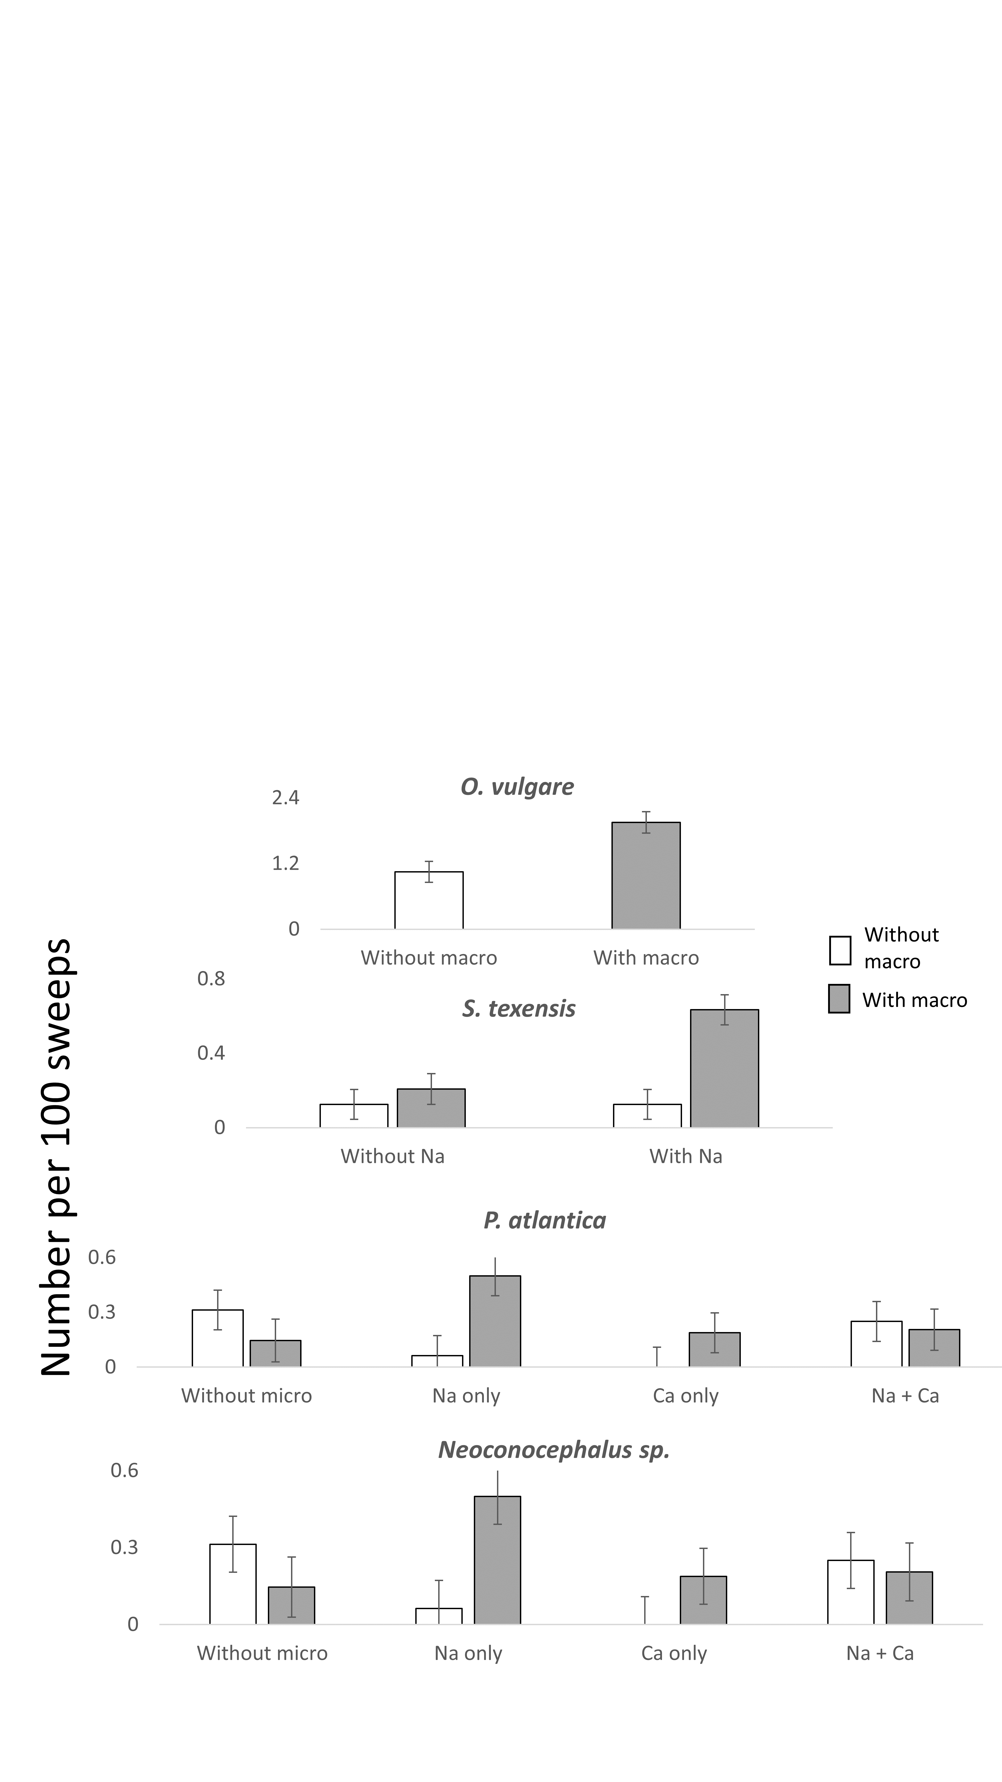

**Supplemental Figure 4.** Species-specific responses to nutrient treatments. Only significant effects are shown. White bars are without macronutrients added; gray bars are with macronutrients added; hatched bars are when macronutrient treatments were pooled. Bars are means ± SE.